Web Programming Activity 5 Test Documentation

30003389 – Kyer Potts

# Test Case

|  |  |  |  |
| --- | --- | --- | --- |
| Test ID | Description | Result | Notes |
| 1.1 | Graph opens in internet explorer | Graph opens and displays the results | Screenshot evidence attached to Screenshot 1.1 |
| 1.2 | Graph data is repopulated and displayed on browser refresh in internet explorer | Data is repopulated and graphed in internet explorer | Screenshot evidence attacked to Screenshot 1.2 |
| 2.1 | Graph opens in google Chrome | Graph opens and displays the results | Screenshot evidence attached to Screenshot 2.1 |
| 2.2 | Graph data is repopulated and displayed on browser refresh in google Chrome | Data is repopulated and graphed in google Chrome browser | Screenshot evidence attached to Screenshot 2.2 |
| 3.1 | Graph opens in Mozilla Firefox | Graph opens and displays the results | Screenshot evidence attached to Screenshot 3.1 |
| 3.2 | Graph data is repopulated and displayed on browser refresh in Mozilla Firefox | Data is repopulated and graphed in Mozilla Firefox browser | Screenshot evidence attached to Screenshot 3.2 |
| 4.1 | Ensure that graph is displayed with randomised results over multiple iterations | Graph displays randomised results | Screenshot evidence attached to Screenshot 4.1 |
| 4.2 | Ensure that graph is displayed with randomised results over multiple iterations | Graph displays randomised results | Screenshot evidence attached to Screenshot 4.2 |
| 4.3 | Ensure that graph is displayed with randomised results over multiple iterations | Graph displays randomised results | Screenshot evidence attached to Screenshot 4.3 |
| 4.4 | Ensure that graph is displayed with randomised results over multiple iterations | Graph displays randomised results | Screenshot evidence attached to Screenshot 4.3 |
| 4.4 | Ensure that graph is displayed with randomised results over multiple iterations | Graph displays randomised results | Screenshot evidence attached to Screenshot 4.4 |

# Screenshot Evidence

### Screenshot 1.1

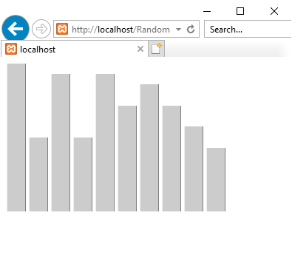

### Screenshot 1.2

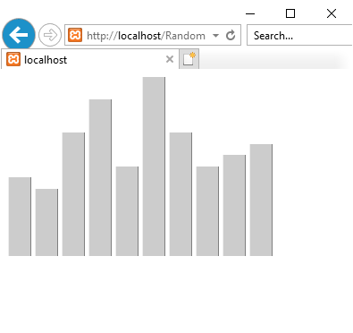

### Screenshot 2.1

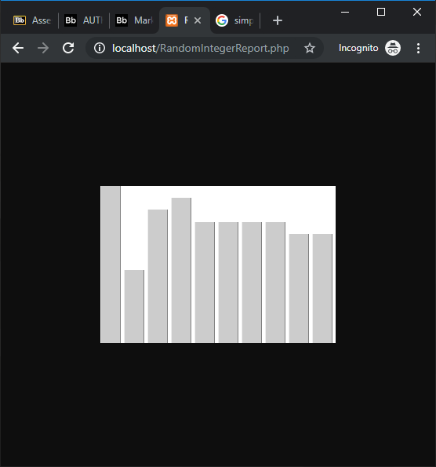

### Screenshot 2.2

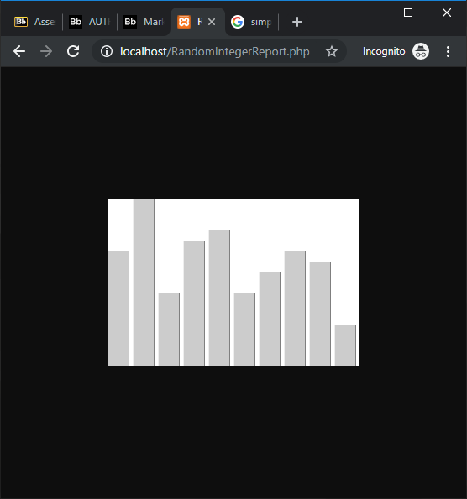

### Screenshot 3.1

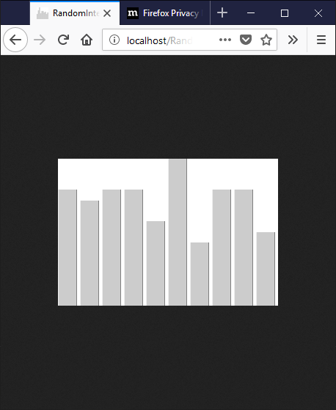

### Screenshot 3.2

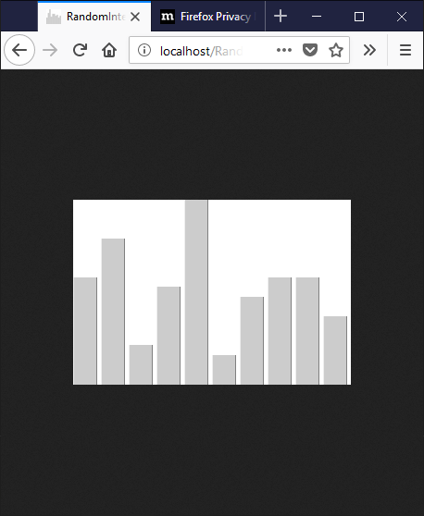

### Screenshot 4.1

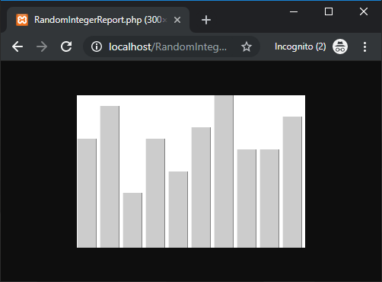

### Screenshot 4.2

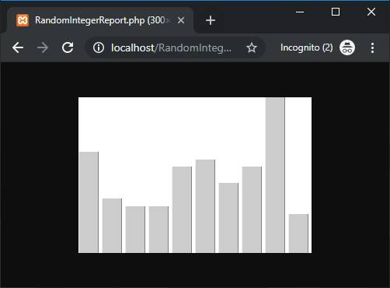

### Screenshot 4.3

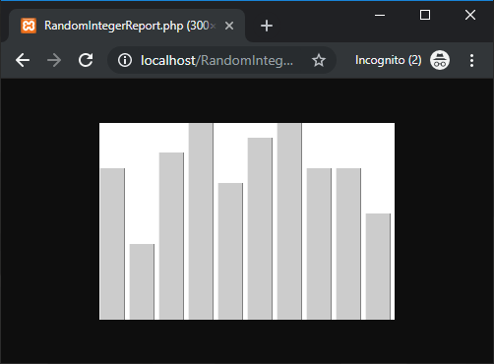

### Screenshot 4.4

